Functional Requirements

- Coordinate Group Creation:

Users can create a coordinate group consisting of both Cartesian and polar coordinates.
Input one type of coordinate (either Cartesian or polar), and the software should handle the conversion to the other type.
A coordinate group consists of:
Cartesian: (x, y)
Polar: (r, θ)

- Coordinate Group Storing:

Store coordinate groups in a MySQL database with the following attributes:
Unique auto-generated identifier (integer).
User-defined string label for identification.
Automatically assigned timestamp.

- Coordinate Group Retrieval:

Retrieve coordinate groups either by:
Label: Search using a user-defined string label.
View all: Retrieve and display all saved coordinate groups.

- Coordinate Group Modification:

Select and modify details of a coordinate group (Cartesian or polar values, label) and save the updated version.

- Coordinate Group Deletion:

Delete a coordinate group from the database.

Non Functional Requirements

Frontend: Developed using Java with the Swing framework for user interaction.
Database: MySQL for persistent storage of coordinate groups.
TCP/IP Connection: To handle the communication between the application and the database.

Prompt

Task Description:
You are tasked with processing a software description and its requirements to generate a class diagram using PlantUML. The class diagram should respect the requested software architecture, define all necessary classes, and accurately represent associations between them.

Overview:
The Dummy Coordination Conversion (DCC) Application is a software system that manages coordinate groups in both Cartesian and polar formats. The system allows users to convert, store, retrieve, modify, and delete coordinate groups.

Software Architecture: {Architecture}

Functional Requirements: {FR}

Non-Functional Requirements: {NFR}

Generate a class diagram using PlantUML that defines all necessary classes and associations based on the described architecture, requirements, and functionality. Ensure that:
The diagram reflects the separation of concerns based on the requested architecture.
Each class is properly defined with attributes and methods.
All associations (e.g., composition, aggregation, or inheritance) between the classes are included in plantUML and are clearly represented.
Create the appropriate packages to include the classes.

Functional Requirements

- Logic:
  - Define cartesian coordinates as a pair (x, y) of high-precision numbers
  - Define polar coordinates as a pair (r, θ) of high-precision numbers
  - Convert cartesian (x, y) to polar (r, θ) coordinates
  - Convert polar (r, θ) to cartesian (x, y) coordinates
  - A coordinate group contains cartesian (x, y) and polar (r, θ) coordinates

- Data operations:
2.1 CreateOp: create a unique auto-generated integer identifier (id) for the coordinate group edited, add a timestamp, and save the label and the values of the coordinates group as a new record into the database
2.2 ReadOp: Create a list of all saved coordinate group records. For each record, show: id, label, cartesian coordinate values, polar coordinate values, datetime added or modified), sorted by id
2.3 UpdateOp: Update a coordinate group record with new values entered by the user and save the updated record of the coordinates group into the database
2.4 DeleteOp: Delete a coordinate group record from the database

- User interactions:
3.1 Input one new coordinate group and one string to label the group
3.2 When the user inputs cartesian coordinates (x, y), calculate the corresponding polar (r, θ) coordinates by converting cartesian to polar
3.3 When the user inputs polar coordinates (r, θ), calculate the corresponding cartesian coordinates by converting polar to cartesian
3.4 When "add" is selected, execute CreateOp for the current values of the coordinate group and the label
3.5 When "update" is selected, execute the UpdateOp for the selected record in the list created by the ReadOp
3.6 When "delete" is selected, execute the DeleteOp for the selected record in the list created by the ReadOp
3.7 When initializing and when "add", "update" or "delete" is executed, refresh and display the list created by the ReadOp
3.8 Filter the list of coordinate groups displayed, by a label value entered by the user
3.9 Clear the active filter and display all saved coordinate group records, as in 3.7

Non Functional Requirements

Frontend: To be developed using Java with the Swing framework for user interaction
Logic: To be developed using Java classes, according to the object-oriented design principles
Database server: MySQL for persistent storage of coordinate groups
Database connection: TCP/IP connection for the communication between the application and the database
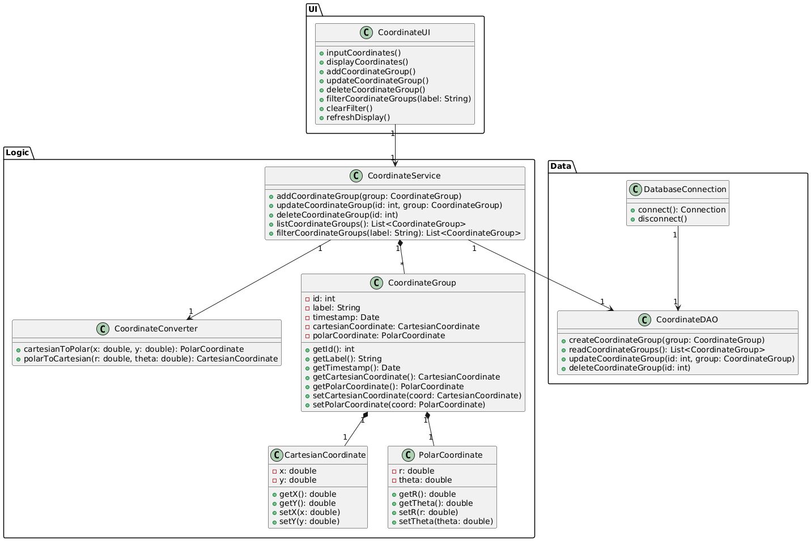
Design: Apply the "Single Responsibility Principle"

PROMPT

Task Description:
You are tasked with processing a software description and its requirements to generate a class diagram using PlantUML. The class diagram should respect the requested software architecture, define all necessary classes, and accurately represent associations between them.

Overview:
The Toll Manager application is an information system that acts as an independent entity to ensure interoperability between the toll systems of different highway operators. The system must receive and store vehicle passage data from the toll systems of various operators, calculate financial settlements between operators based on vehicle passages, and also provide data analysis services and access to stakeholders.

Software Architecture: Three Tier Architecture

Functional Requirements: {FR}

Non-Functional Requirements: {NFR}

Generate a class diagram using PlantUML that defines all necessary classes and associations based on the described architecture, requirements, and functionality. Ensure that:
The diagram reflects the separation of concerns based on the requested architecture.
Each class is properly defined with attributes and methods.
All associations (e.g., composition, aggregation, or inheritance) between the classes are included in plantUML and are clearly represented.
Create the appropriate packages to include the classes.

Functional Requirements
- Coordinate Group Creation:

Users can create a coordinate group consisting of both Cartesian and polar coordinates.
Input one type of coordinate (either Cartesian or polar), and the software should handle the conversion to the other type.
A coordinate group consists of:
Cartesian: (x, y)
Polar: (r, θ)

- Coordinate Group Storing:

Store coordinate groups in a MySQL database with the following attributes:
Unique auto-generated identifier (integer).
User-defined string label for identification.
Automatically assigned timestamp.

- Coordinate Group Retrieval:

Retrieve coordinate groups either by:
Label: Search using a user-defined string label.
View all: Retrieve and display all saved coordinate groups.

- Coordinate Group Modification:

Select and modify details of a coordinate group (Cartesian or polar values, label) and save the updated version.

- Coordinate Group Deletion:

Delete a coordinate group from the database.

Non Functional Requirements

Frontend: To be developed using Java with the Swing framework for user interaction
Logic: To be developed using Java classes, according to the object-oriented design principles
Database server: MySQL for persistent storage of stations, passes, etc
Database connection: TCP/IP connection for the communication between the application and the database
Design: Apply the "Single Responsibility Principle"

